|  |  |  |
| --- | --- | --- |
| SCHOOL OF INFORMATION AND TECHNOLOGY | | |
| NAME: BUSONGAN, DEMIRAYE-ANNE | DATE PERFORMED: 09 OCT 24 | /50 |
| Section: IDC1 | DATE SUBMITTED: 16 OCT 24 |

# SYSADM1 – Setting Up Webserver

# Requirement:

* A virtual machine running Linux and Windows OS

Task Instructions:

1. Install IIS by adding it as a role, select necessary features, include monitoring tools

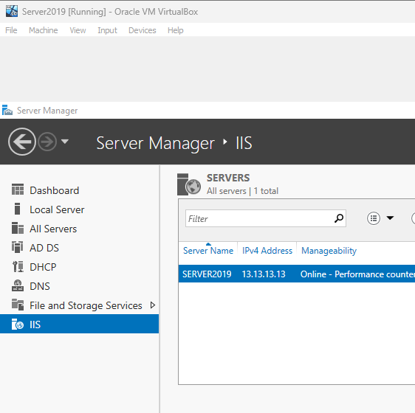

1. Create a website by opening IIS Manager
   * Right-click on the server’s name and select Internet Information Services Manager.
   * Right-click on Sites and select Add Website.  
     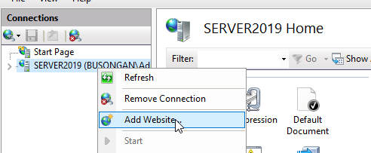
   * Enter a name, description, physical path (where your website files will reside), IP address, port, and host name.  
     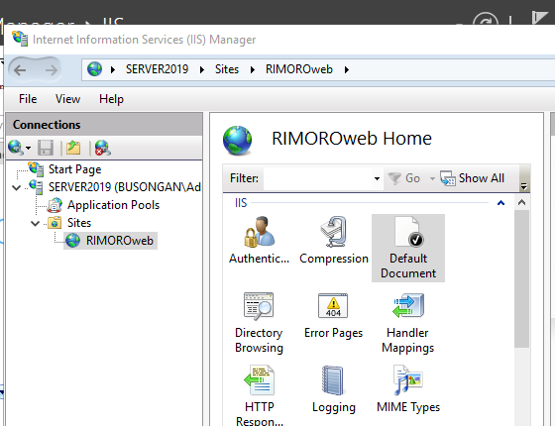
2. Configure the Website:
   * Right-click on your website and select Edit.  
     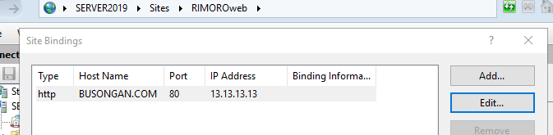
   * Set the Default Document to the name of your main HTML file >default.html
   * Configure other settings as needed (e.g., SSL certificates, authentication)



1. Create a Web Page:
   * Create an HTML file in the physical path you specified.



* + Save it as default.html or your preferred name.

1. Test the Web Server:
   * Open a web browser and enter the URL of your website (e.g., http://localhost).
   * You should see your web page displayed.  
       
     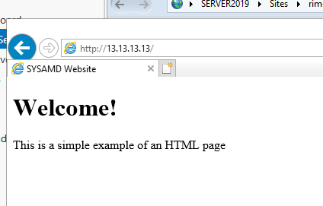

Grading Rubric

|  |  |  |
| --- | --- | --- |
| **Criteria** | **Points** | **Description** |
| Web Server Installation | 15 | Correctly installs IIS or another web server on the virtual machine. |
| Website Configuration | 15 | Successfully configures the website with the correct physical path, IP address, port, and default document. |
| Successful Access | 15 | Successfully accesses the web page from the client computer using the correct URL. |
| Troubleshooting | 15 | Demonstrates ability to troubleshoot common issues, such as network connectivity problems or configuration errors. |
| Documentation | 10 | Provides clear and concise documentation of the installation, configuration, and testing process. |
| Total | /70 |  |